

**PIPSTA004 – Pipsta first-time setup**

Contents

Difficulty Level: 2

Time to Complete: 2

Who Should Read This Document 2

Pre-Requisites 3

Optional Components 3

ESD Warning 4

Micro SD Card Operating System 4

Micro SD Card with NOOBS Preinstalled 4

Installing NOOBS onto a new Micro SD Card 4

Installing Raspbian onto a new Micro SD Card 4

Powering the Unit for the First Time 5

Troubleshooting First-Time Initialisation 5

First Time Launch into Raspbian Wheezy Operating System 6

Joining the Network (Wi-Fi) 7

Joining the Network (Ethernet) 8

Setting-up the USB Drivers and Other Libraries 8

Revision History

|  |  |  |  |  |  |
| --- | --- | --- | --- | --- | --- |
| Revision | Author | Date | | Description | |
| 1.3 | AH/GJ | 27/11/14 | | First Release | |
| 1.4 | AH | 16/12/14 | | Corrected typos in HMDI troubleshooting | |
| Difficulty Level: | | | * No Linux or Raspberry Pi knowledge is required * Some experience of connecting IT peripherals is beneficial * Knowledge of your Wi-Fi settings is required | |
| Time to Complete: | | | * Considerable time is required to create the Micro SD card image * Considerable time is required to download and install the required drivers | |

# Who Should Read This Document

This guide is provided for newcomers to the Raspberry Pi and is intended to take a first-time user through all the necessary configuration steps for Pipsta functionality. At the end of this guide, your Pipsta will be ready to demonstrate stand-alone functions from simple printing to printing QR Codes, banners and more.

Children may need adult supervision and occasional assistance during this process.

# Pre-Requisites

It is expected that you have already built your Pipsta in accordance with:

* ***PIPSTA002 - Pipsta B+ Assembly Instructions***
* ***PIPSTA003 - Pipsta A+ Assembly Instructions***

Although some of the Standalone Pipsta NFC applications do not require keyboard, mouse and monitor, these *are* required during setup, and for all other examples. It is therefore expected that you have the following items:

* Raspberry Pi Model B+ (or Model A+ with 4 port USB hub)
* Power supply for Raspberry Pi (5v, ideally no less than 2.0A rated)
* USB A to Micro B cable assembly (if not integrated into Raspberry Pi power supply)
* Micro SD Card (4GB minimum, 8GB recommended)
* Consider an additional, reserve Micro SD Card!
* Access to two mains sockets for powering the Raspberry Pi and Pipsta printer
* USB Keyboard
* USB Mouse
* A USB Wi-Fi dongle and wireless router in range with known password
* Video/Monitor lead:
  + HDMI lead *or*
  + 3.5mm 4 pole jack plug to RCA composite cable *or*
  + HDMI to VGA adaptor and VGA cable
* Computer monitor or television (with HDMI, component video or VGA input as above)
* Access to a Linux/Windows/Mac system with:
  + Micro SD card port (or Micro SD card USB adaptor)
  + Browser and internet connection
* An ESD Wrist-strap

|  |  |  |
| --- | --- | --- |
|  | **TIP**: | A 5v 1.2A is adequate for Raspberry Pi systems with few or no connected USB devices, but for systems with keyboards, mice and Wi-Fi dongles connected, a 5v 2.0A (or greater) rated supply is advisable. It is also worth noting that use of USB power supplies with lower power ratings can lead to USB devices becoming non-responsive and unstable Raspberry Pi operation and ultimately even a corrupted Micro SD card image. |

## Optional Components

The Pipsta NFC features are most readily demonstrated by means of an NFC enabled smart-phone. The Android app “*Pipsta NFC Printer*” has been developed to demonstrate these capabilities and can be downloaded from the Google Play store.

NFC capabilities were introduced in Android 2.3.3 (*Gingerbread*). Please ensure that your NFC enabled Android phone runs this or a later Android operating system.

# ESD Warning

Both the Raspberry Pi and Pipsta thermal mini-printer are sensitive to damage by Electro-Static Discharge (ESD). You must ensure that you observe ESD handling precautions before handling any components. Please note that it is possible to damage these devices even by being in close proximity to them (i.e. without touching.) For best practice in ESD handling precautions, please visit <http://www.esda.org/>

# Micro SD Card Operating System

There are three likely scenarios:

1. You have obtained a Micro SD card with NOOBS (New Out-Of-Box Software),
2. You have a new Micro SD card and want to use NOOBS to install Raspbian, or
3. You have a new Micro SD card and want to install Raspbian only.

## Micro SD Card with NOOBS Preinstalled

Simply fit the Micro SD card into the front of the Raspberry Pi (heeding the orientation) before proceeding to *‘Powering the Unit for the First Time’*

## Installing NOOBS onto a new Micro SD Card

1. Using your PC/Mac, download the NOOBS image from the ‘downloads’ section of the Raspberry Pi website:

<http://www.raspberrypi.org/downloads/>

1. Extract/Unzip all the files from the downloaded file
2. Connect the Micro SD card slot of the Linux/PC/Mac system (via USB adaptor if required)
3. Copy the files from the extracted NOOBs folder to the Micro SD card. DO NOT copy the folder itself: the files themselves should be copied to the root of the card.
4. Fit the Micro SD card into the front of the Raspberry Pi (heeding the orientation) before proceeding to *‘Powering the Unit for the First Time’*

## Installing Raspbian onto a new Micro SD Card

1. Using your PC/Mac, download the Raspbian OS image from the ‘downloads section of the Raspberry Pi website:

<http://www.raspberrypi.org/downloads/>

1. Extract/Unzip all the files from the downloaded file
2. Connect the Micro SD card slot of the Linux/PC/Mac system (via USB adaptor if required)
3. Follow the instructions outlined at:

<http://www.raspberrypi.org/documentation/installation/installing-images/README.md>

1. Fit the Micro SD card into the front of the Raspberry Pi (heeding the orientation) before proceeding to *‘Powering the Unit for the First Time’*

|  |  |  |
| --- | --- | --- |
|  | **TIP**: | It is worth noting that –should your Raspberry Pi become unstable—you may have no option but to cycle the power (turn the Pi off and on again.) It is also possible that the power may be accidentally disconnected without having shut the system down properly. Such events can corrupt the image on the Micro SD card, making it either unstable or totally unusable. Aside from a regime of backing-up your own work and archiving of Micro SD card images, you may also want to consider preparing a reserve Micro SD card at this time. There is no necessity to do so, and you may be content with erasing the Micro SD card and re-applying the operating system in the event of such a corruption, but having a Micro SD Card in reserve would limit such down-time. |

# Powering the Unit for the First Time

Please read the following steps as they maximise the chances of successful first-time initialisation:

1. Apply power to the monitor/television
2. Ensure the correct input source is selected on the monitor/television (i.e. HDMI, RCA or VGA)
3. Apply power to the Raspberry Pi
4. If you performed a NOOBs install, you will be presented with a menu. Select Raspbian OS at this time.
5. The Raspberry Pi should now begin booting into Raspbian. If not, please refer to the following section on *Troubleshooting First-Time Initialisation*. The monitor/television (henceforth *screen*) should display the Raspberry Pi symbol at the top left of the screen whilst the rest of the display scrolls through hundreds of initialisation step text lines.

# Troubleshooting First-Time Initialisation

If your problems are not resolved by the advice available at <http://elinux.org/R-Pi_Troubleshooting>, please see below:

Nothing appears on screen:

1. Check the Raspberry Pi is powered. There are LEDs located on the front left-hand side of the Raspberry Pi. You should see a permanently-powered red LED (power indicator). If not, check the power to the Raspberry Pi.
2. Check the Raspberry Pi has ‘disk’ access. In addition to the red power indicator, a green LED should be flickering to indicate ‘disk’ access. If not, check:

* The Micro SD card is properly located and cycle the power to the Raspberry Pi
* You have followed the above instructions correctly in terms of applying the disk image.
* If not, suspect damage to the Raspberry Pi

1. Check the screen is powered.
2. Check the screen source is correct.
3. Check the lead is correctly connected.
4. Bypass any HDMI port switchers (if used.) Some HDMI switchers prevent HDMI connections being established.
5. Try an alternative *USB Micro Power Adaptor*. Some cheap power supplies introduce grounding issues which can prevent the establishment of HDMI connections.
6. Try a higher power rated USB power supply.

# First Time Launch into Raspbian Wheezy Operating System

1. Once complete, you will be presented with the Raspberry Pi Software Configuration Tool.

|  |  |  |
| --- | --- | --- |
|  | **TIP**: | Note that –whilst this menu is shown automatically only during first-time initialisation—it can easily be brought-up at a later time (covered in a later tutorial.) |

The menu will look something like this:

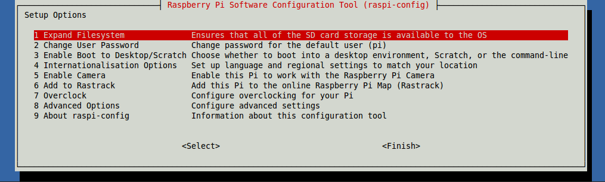

1. At this stage you should select options 1 and 3 to permit access to the full capacity of your Micro SD Card, and ensure that you are taken into the graphical user interface desktop environment. The latter option will bring up a second menu: you should select ‘*Desktop log in as user ‘pi’ at the graphical desktop’*
2. Once you have applied these options, press the right arrow to move to <Finish> and press [Return]. You will be asked if you wish to reboot: select <Yes> and press [Return].
3. The system will now reboot and you will be taken to the standard Raspberry Pi desktop environment:

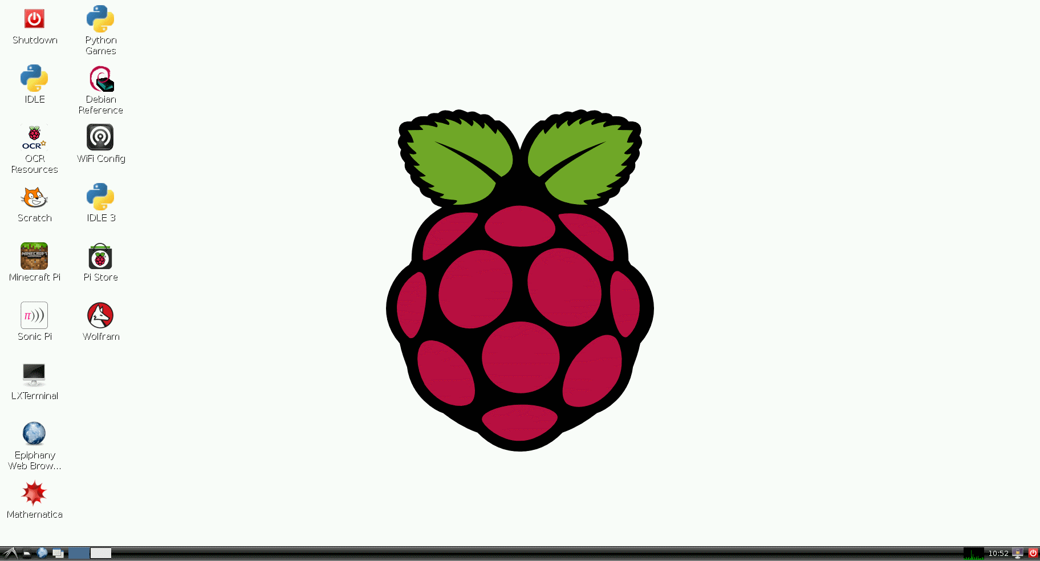

# Joining the Network (Wi-Fi)

1. Double-click 'Wi-Fi Config' on the desktop. You should be presented with the following screen:

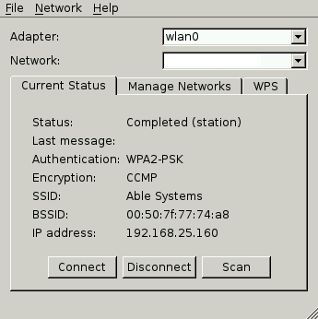

Note that –if there is nothing listed in the ‘Adaptor’ field—you should check your Wi-Fi dongle is correctly connected.

1. Click the 'Scan' button. A scan of local Wi-Fi networks will be performed:

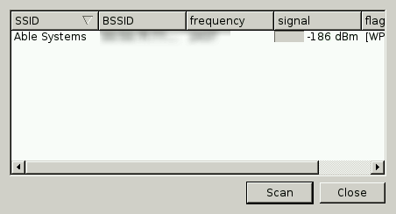

1. On completion, select your preferred network:

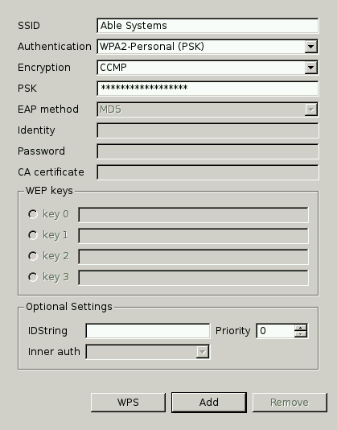

1. Enter your network password in the PSK textbox and click 'Add'
2. The 'wpa_gui' should now update as the Raspberry Pi is connected to the network. Upon completion, close this window.
3. Test your connection by launching Epiphany Web Browser from the Raspberry Pi desktop.

# Joining the Network (Ethernet)

Consult your IT technician for assistance in joining the Ethernet network.

# Setting-up the USB Drivers and Other Libraries

1. Launch LXterminal from the Raspberry Pi desktop. You should be presented with the following prompt:



1. At the $ prompt, enter:

sudo apt-get update

|  |  |  |
| --- | --- | --- |
|  | **TIP**: | Note that Linux is case-sensitive. |

The Raspberry Pi will automatically locate and update the resident software with the latest versions available on the internet.

1. At the $ prompt, enter each of the following commands. Note that this sequence will take a considerable amount of time (tens of minutes), and that some commands will require subsequent installation confirmation (pressing ‘Y’ to continue):

sudo apt-get install python-pip

sudo apt-get install python-dev

sudo pip install bitarray pyusb

sudo pip install pillow

sudo pip install qrcode

1. Locate and double-click the ‘File Manager’ button on the task bar:



1. The File Manager should show the following screen:

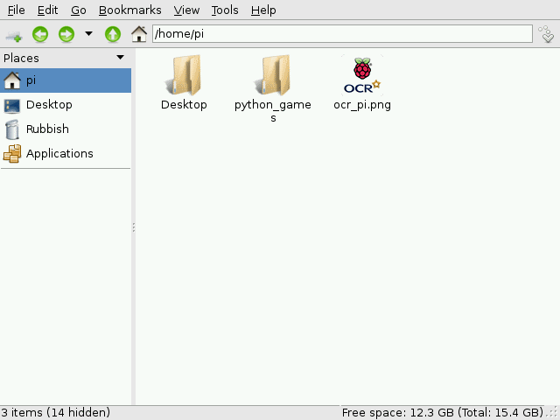

1. Using the browser, go to <https://bitbucket.org/ablesystems/pipsta>
2. Follow the instructions in the Read Me section, this is best viewed at the above web page as it is a markdown script.

◼**End of Document**◼